Adding Abstracts to the Poster Site
Below are all the instructions/access needed to add the Abstracts from JotForm to the Poster site.
Login Details
- Website login: https://poster.bwh.harvard.edu/wp-login.php
- Username:
- Password:

Adding Abstracts
For the time being the abstracts can be added from the excel file titled “Abstracts for PosterSite” which is in the “Poster Site Tutorial – Discover Brigham” teams chat under “Files”.

Please Note: When you finish adding a poster to the poster site, be sure to indicate on the excel sheet by striking through or graying out the name.

Steps: Adding Abstracts To The Poster Site
- Login to the Poster site: https://poster.bwh.harvard.edu/wp-login.php
- Click on posts > Add new post
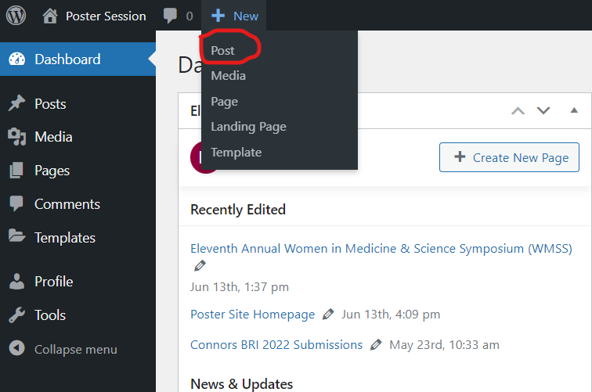
- Add presenter’s name with degree (e.g. Jane Doe, DDS) as post title (using name in JotForm)
- Assign poster category (This will show the pop up fields to enter abstract data)
- Begin adding the rest of the information from the JotForm submission
- Add type of research in post tag
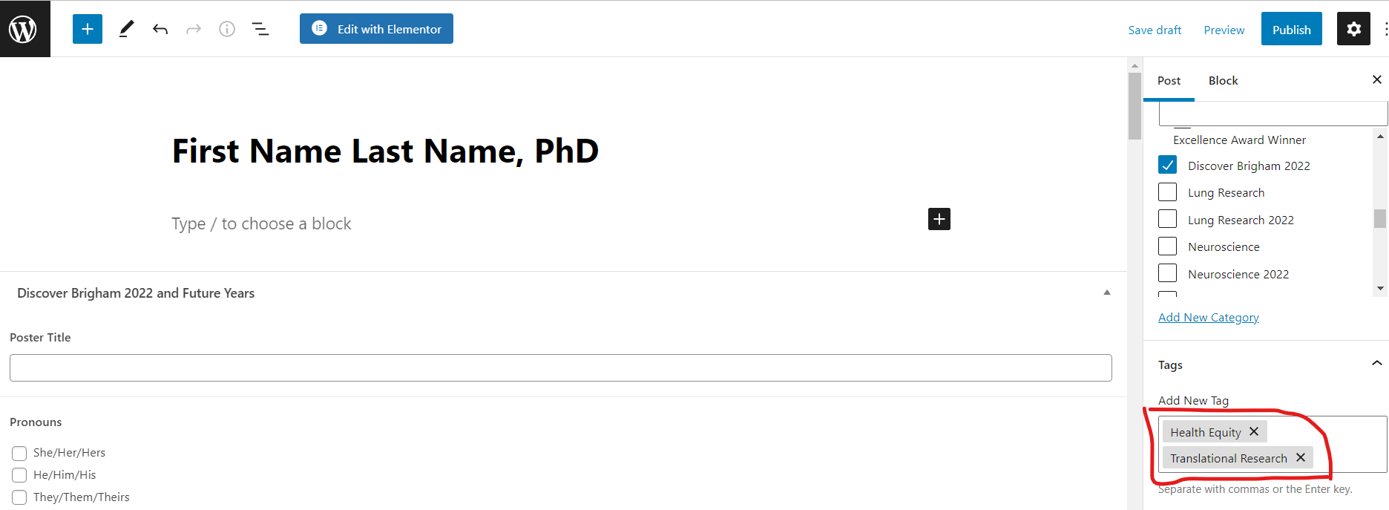

- Add poster/presentation PDF’s URL in the custom field (if any)
- Publish and view post

