1. **Open your presentation in PowerPoint (Office 365)**  
   Make sure you're using a version that supports *Cameo* (PowerPoint for Microsoft 365 on Windows or Mac).
2. **Insert your camera feed (Cameo)**
   * 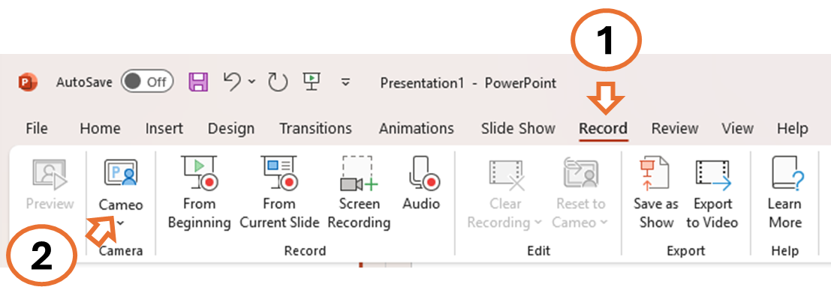Go to the **Record** tab → Click **Cameo**.
   * A live camera feed will appear on the slide.
   * Resize and move it to a suitable spot on each slide.
   * 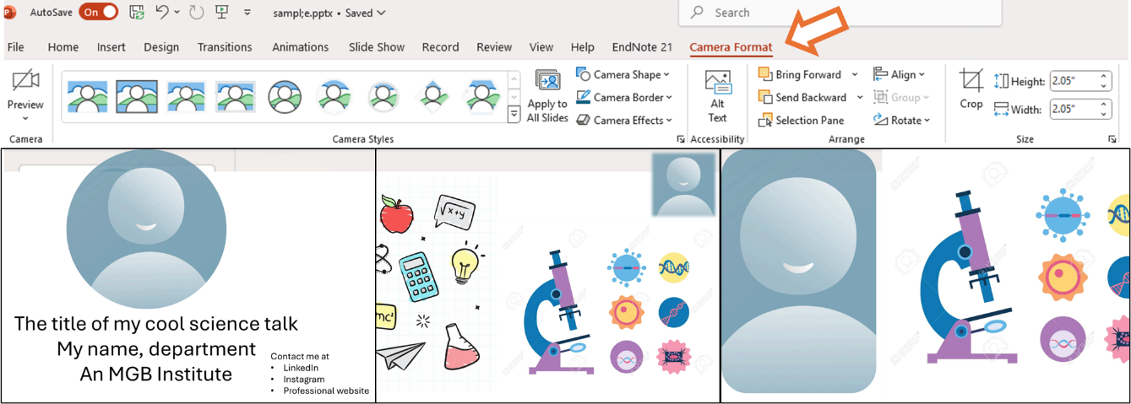You can adjust the camera style under **Camera Format** (e.g., shape, border, effects).
3. **Record your presentation**
   * Go to the **Recording** tab → Click **Record Slide Show** → Choose **From Beginning** or **From Current Slide**.
   * Record your narration and camera feed (Cameo) while presenting.
   * Use **Pause**, **Resume**, or **Stop** as needed.
4. **Review or re-record**
   * Playback your recording using **Play from Start**.
   * To re-record a specific slide, go to that slide and choose **Record from Current Slide**.
5. **Export the presentation**
   * File → Export → Create a Video → Choose quality.
   * Click **Create Video** to save it as an MP4.